**Sentiment Analysis of COVID-19 Tweets – Visualization Dashboard**

# **Index**

|  |  |
| --- | --- |
| 1. | Introduction |
| 2. | Project Description/working |
| 3. | Results |
| 4. | Applications |
| 5. | Conclusion |
| 6. | Bibliography |

# **Introduction**

Sentiment Analysis is a technique widely used in text mining. Twitter Sentiment Analysis, therefore means, using advanced text mining techniques to analyze the sentiment of the text (here, tweet) in the form of positive, negative and neutral.

# **Project Description**

Here in our project, we used IBM cloud platform to analysis COVID-19 data set to get the reaction/sentiment of the user that is positive, negative, neutral towards the pandemic

In IBM cloud firstly we created Watson Studio service and Machine Learning service instance.

Under Watson studio service we create an AutoAI project and did the Analysis of our Data set And deployed the Model

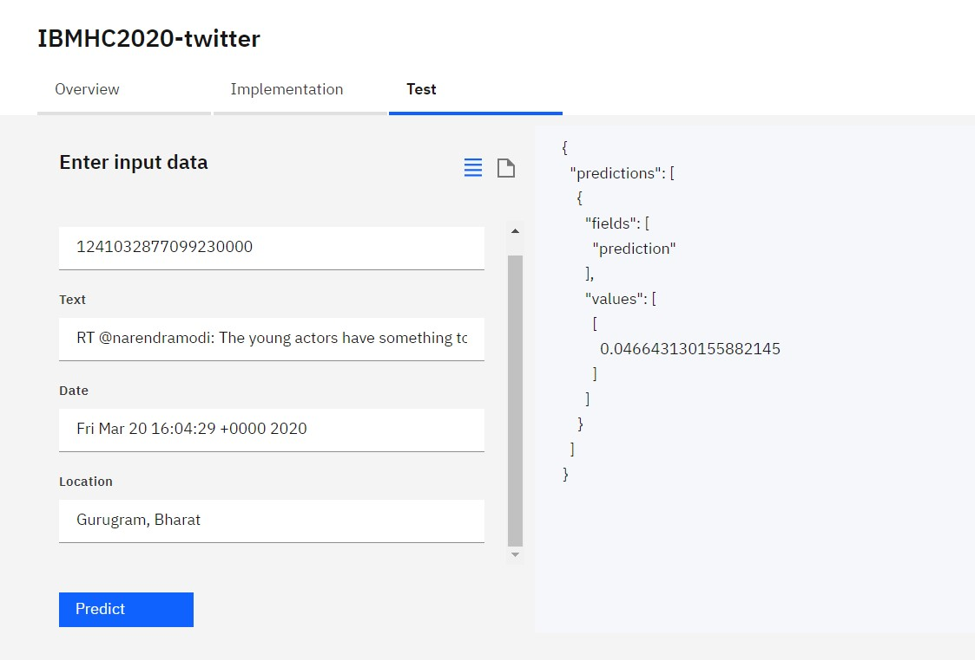

After completing our Analysis part we then created node-red service in IBM cloud. And start working on flow.

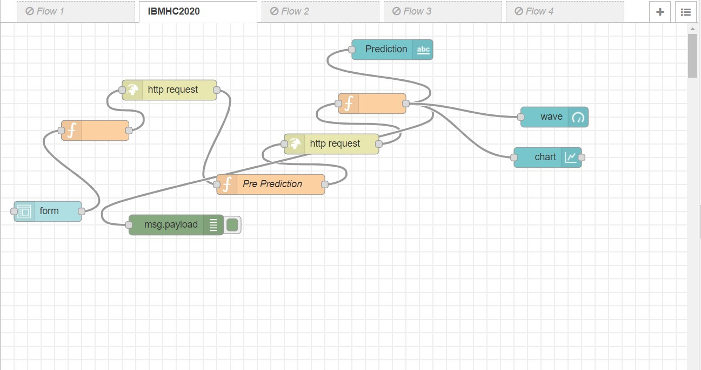

# 

# **UI Interface**

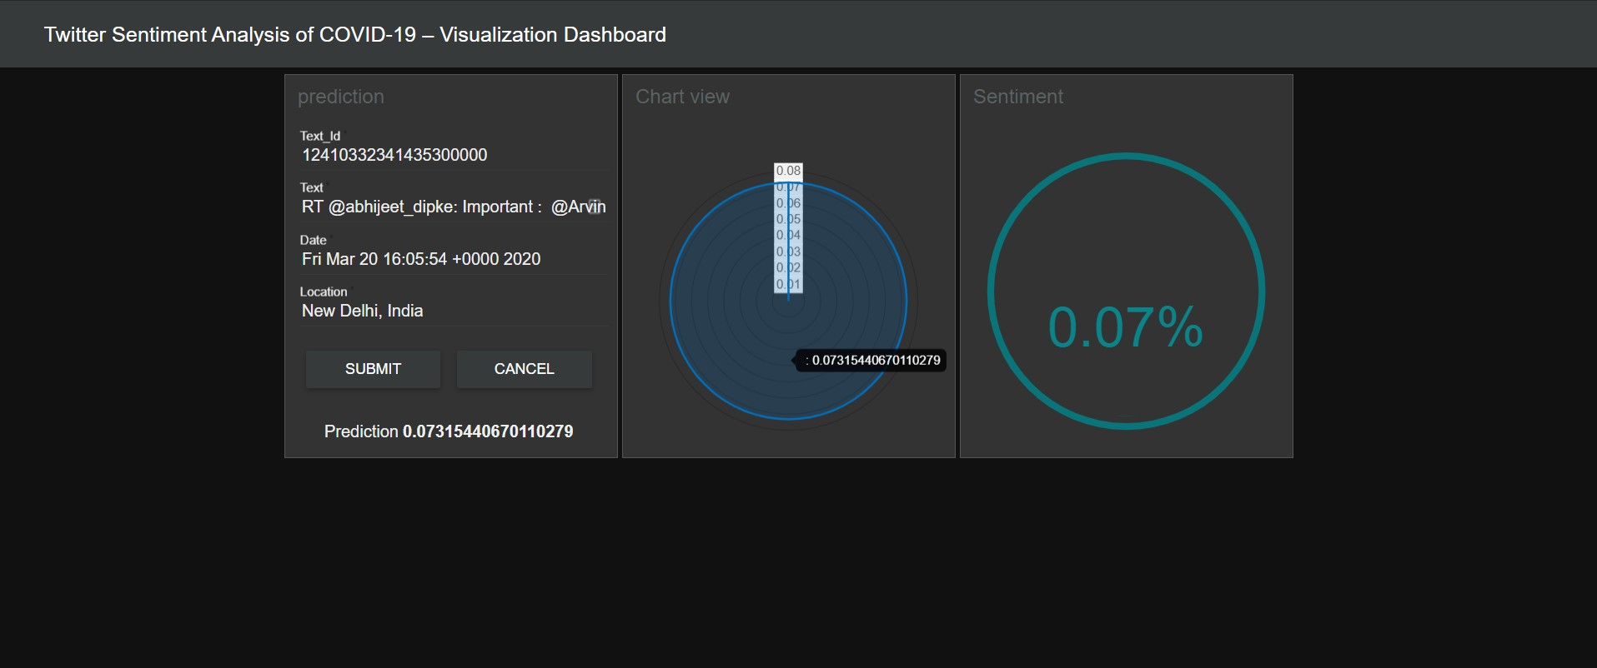

# **Results**

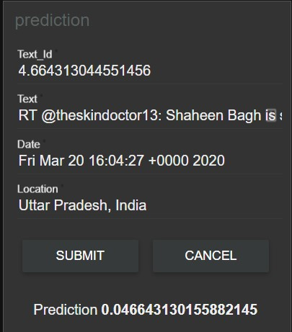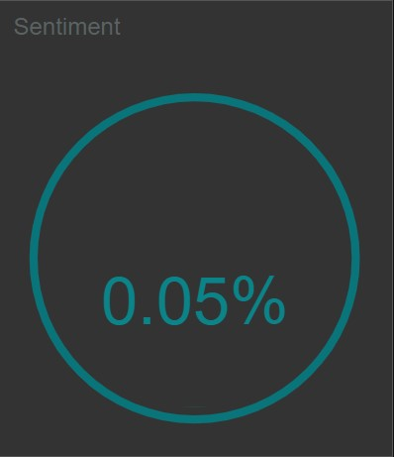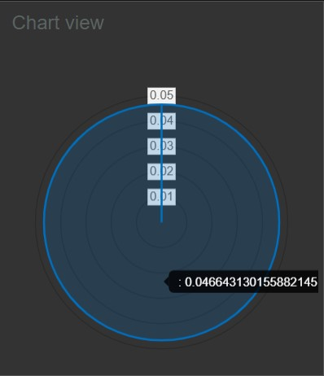

Website link:-<https://node-red-hnyij.eu-gb.mybluemix.net/ui/#!/0?socketid=i6s-dpSN4aaRJYVpAABE>

# **Application**

1. Get to know people’s sentiment towards the epidemic
2. Understand the sentiments of people on government The decision to extend the lockdown

# **Conclusion**

The sentiment analysis of COVID- 19 Data set of Indians in the form of twitter tweets helps us to predictive / understand the behaviour of people towards the pandemic this data can be used by government, small and large business to know what people/ users want in this epidemic period

# **Bibliography**

1. [**https://youtu.be/e70ta8jI_nM**](https://youtu.be/e70ta8jI_nM)
2. [**https://www.youtube.com/playlist?list=PLjlJJFiCdXMInlWHEsgsnY3P55kGdSDh_**](https://www.youtube.com/playlist?list=PLjlJJFiCdXMInlWHEsgsnY3P55kGdSDh_)